Foundations of Mechanical CAD
  - Week 1 Report
Student KUGANRAJ K
Focus SolidWorks mechanical parts

Purpose and scope
Mechanical computer aided design (CAD) uses digital tools to define the shape, size and relationships of engineering components. This report introduces the main concepts, outlines a suitable learning setup and reviews the supplied SolidWorks drawing. The drawing provides an example of CAD output; a separate screenshot is still needed to demonstrate the working software environment.

Core concepts
A typical parametric model begins with a two dimensional sketch on a reference plane. Dimensions control size, while constraints such as concentric, tangent and coincident control geometric relationships. A fully constrained sketch has no unintended freedom to move. Design intent describes how the model should behave when a dimension changes.
Features turn sketches into three dimensional geometry. An extrusion adds depth, a revolution rotates a profile about an axis, and a cut removes material. Fillets round edges and chamfers bevel them. The feature history records the modeling sequence and allows earlier decisions to be edited.
A part represents one component. An assembly combines components using mates or constraints to control their positions and movement. A drawing communicates the design through orthographic, section and isometric views, dimensions, tolerances, material and manufacturing notes. Dimensions specify intended geometry; tolerances specify permissible variation.

SolidWorks and CATIA
SolidWorks supports parametric part modeling, assemblies and engineering drawings. CATIA also supports these activities and is used for complex product design, including advanced surface modeling. For this introductory exercise, either tool can be used to practise sketches, features and drawings. Access to one tool does not demonstrate that the other has been installed or tested.

Professional working practice
A typical workflow is to review requirements, select units and reference planes, create constrained sketches, build features, check dimensions and prepare drawings. Designers use clear feature names and controlled revisions, check assembly fit and consider manufacturing access. Before release, they verify materials, tolerances and drawing completeness rather than relying on the appearance of a model alone.

CAD Example and Setup Evidence
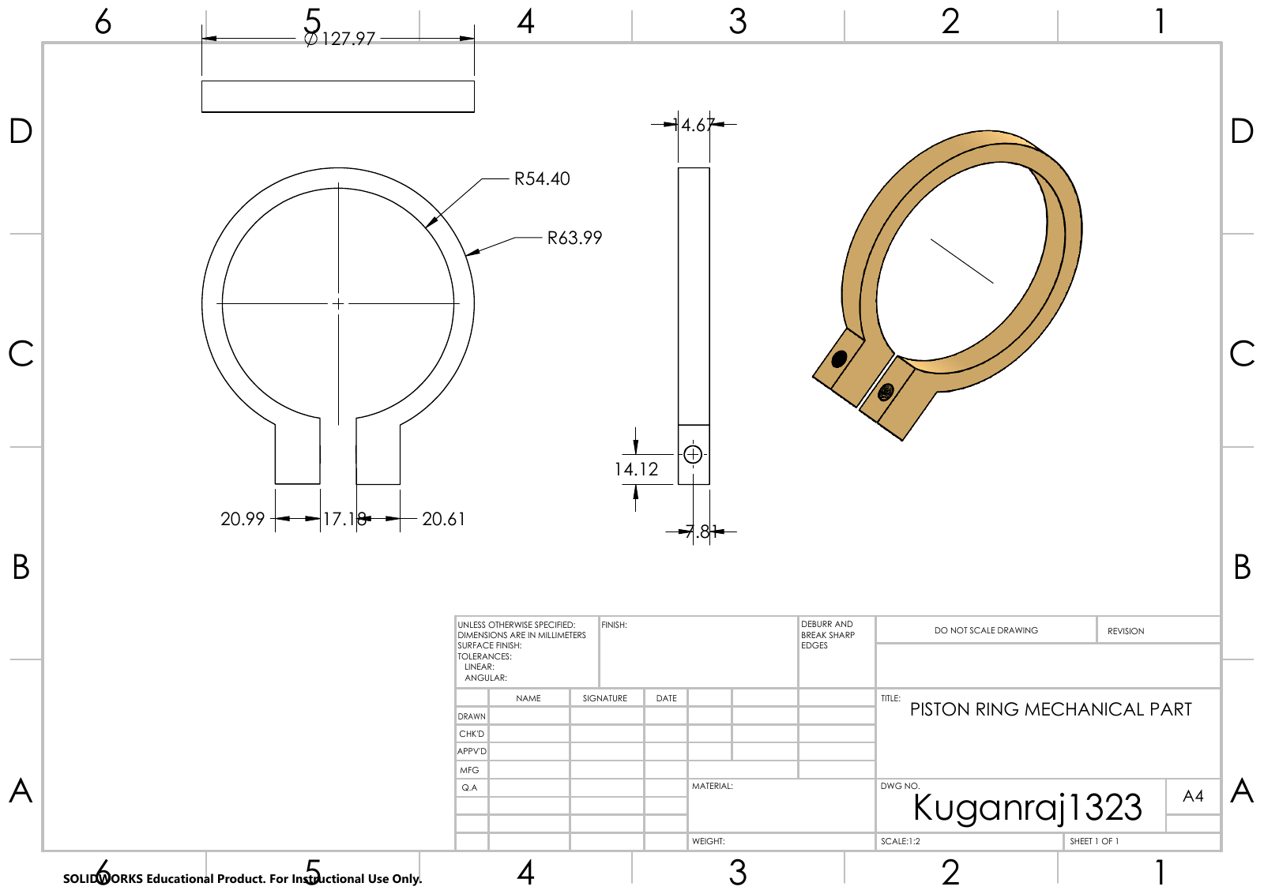
Figure 1 Drawing reproduced from the supplied Kuganraj assy 1.pdf.
The supplied sheet is titled Piston Ring Mechanical Part and carries a SolidWorks Educational Product label. It includes orthographic and isometric views, millimetre units and a stated scale of 1:2. The inner and outer radii are labelled R54.40 and R63.99. The title block leaves material and tolerance information unspecified, so these would need clarification before manufacturing. This review does not verify a native CAD model or a completed installation.

Working environment setup
Use an authorised SolidWorks or CATIA installation and check the requirements for the available version. Create a project folder with separate locations for parts, assemblies and drawings. Start a new part, select millimetre units and practise a constrained sketch followed by an extrusion. Save the native file, reopen it and confirm that it rebuilds successfully. These steps are a setup guide; their completion has not been verified here.

Conclusion
Mechanical CAD connects constrained sketches, editable features and engineering drawings. The supplied part drawing illustrates how a component can be communicated in several views. The remaining evidence for this task is an actual screenshot showing the working CAD environment.

